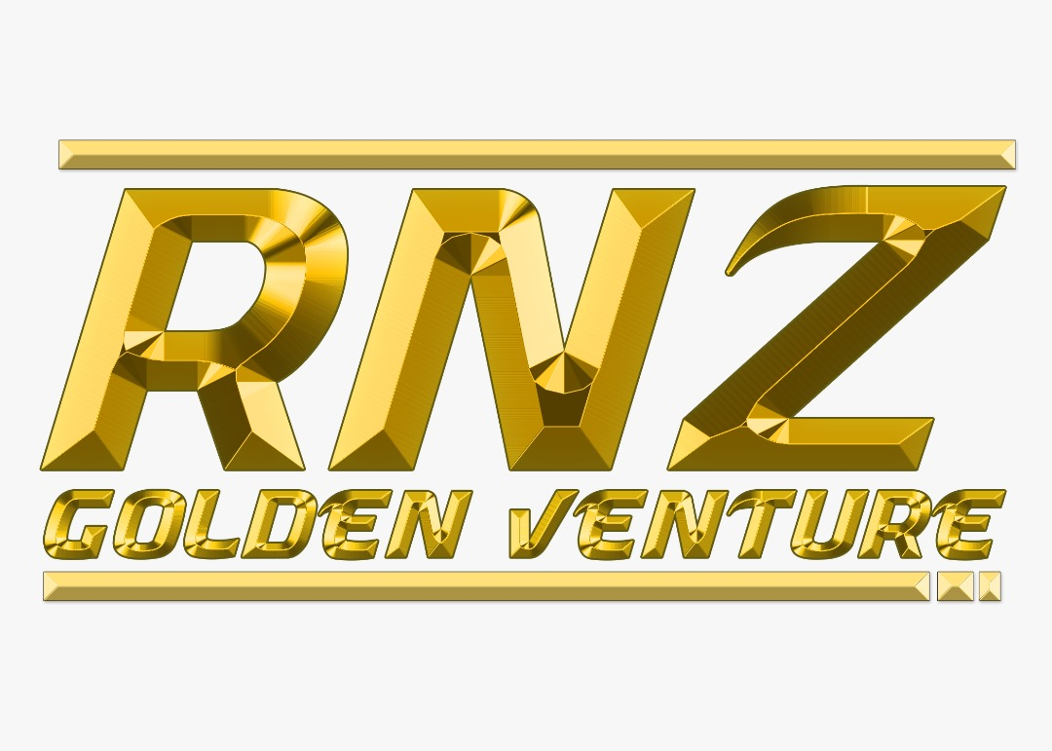 RNZ GOLDEN DEVELOPMENT SDN. BHD.

**INTRODUCTION**

RNZ Golden Development Sdn Bhd is a leading civil engineering and infrastructure company that embodies sustainable construction in all our projects. Established in 2016, RNZ Golden Development Sdn Bhd have completed numerous successful projects such as civil and building works in Pengerang, Johor for Pengerang Integrated Petroleum Complex (PIPC).

RNZ Golden Development Sdn Bhd is a reputable company with strong focus on long-term business stability and environmental sustainability. We are trusted by our clients for our first class services and performance all over the country. Our goal is to help you design and build your most efficient access system.

Since 2016, we have diversified our business into various sectors and with the right team of highly skilled and certified workers, we make the process easy and your experience an enjoyable one. As a full-fledged service company with wide range of experience, RNZ Golden Development Sdn Bhd can assist in all phases of new construction, restorations or plant operation and maintenance projects.

**Vision**

To be the leading scaffolding, civil & mechanical organisation with dedication fulfill client’s satisfaction by following standards of industry regulations, safety, health and environment.

**Mission**

We are committed to contribute our utmost integrity in our services with the best team of management and competent skilled workers to maintain the highest quality of job and customer satisfaction in our current and new upcoming projects.

Our mission supports our spirit which is very alive in our daily activities. Our company culture represents the fast paced industry spirit of a 24/7 attitude, combined with a determination to comply with our promises and to satisfy our clients and business relations

RNZ GOLDEN DEVELOPMENT SDN. BHD.

ORGANIZATION CHART

RNZ GOLDEN DEVELOPMENT SDN. BHD.

NATURE OF BUSINESS

1. **CIVIL STRUCTURE**

We specialize on industrial construction projects which involves construction of foundation complete structure and civil works such as administration building, warehouse, workshop, equipment foundation, RC foundation and many more. Some of the work we do are:

-RC Slab & Wall For Bullet Tank

-RC Foundation and Pit for Machinery and Pipe Rack

-SWA Drainage

-Concrete Pavement

-RC Structure

-Road Works

-Roofing and Cladding Works

**2. ARCHITECTURAL WORKS**

We offer full range of general contracting services mainly in civil and architectural works. We focus on internal and external finishes which includes:

-Structural Repair to Building

-Industrial Building Painting

-Water Proofing

-Raised Floor System

-Epoxy Flooring

-Insulated Wall

-Acoustic Wall and Ceiling

-Dry Wall System

RNZ GOLDEN DEVELOPMENT SDN. BHD.

NATURE OF BUSINESS

**3. INDUSTRIAL CONSTRUCTION**

We specialise on industrial construction projects which involves construction of foundation complete structure and civil works such as administration building, ware house, workshop, equipment foundation, RC foundation and many more. Some of the work we do are:

-System Furniture

-Loose Furniture

-Acoustic Wall

-Mounted Glass Writing Board

-Dry Wall System

-Feature Ceiling

**4. MECHANICAL WORKS**

Our expertise in mechanical work includes:

-Fabrication & Installation of Metal Piping System

-Erection Of API 650 Storage Tank

-Fabrication & Installation of Structural Steel Work

-Erection of Spherical Tank and Ancillary Work

RNZ GOLDEN DEVELOPMENT SDN. BHD.

OUR PROJECTS

1. **Engineering, Procurement, Construction And Commisission (EPCC) Of Rapid Excess LP Steam Turbine Generator**

Project Title : Engineering, Procurement, Construction And Commisission (EPCC)

Of R Rapid Excess LP Steam Turbine Generator

Customer : Petroliam Nasional Berhad

Main Contractor : MIE Industrial Sdn Bhd

Job Scope : Concrete Cable Trench

Location : Rapid Package 33, Pengerang, Johor

Project Duration : Oct 2019 – Sept 2020

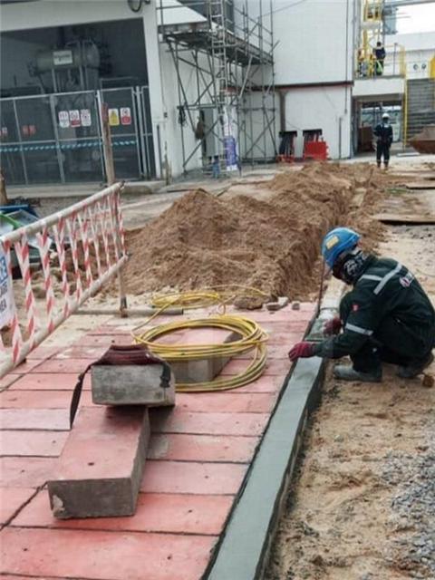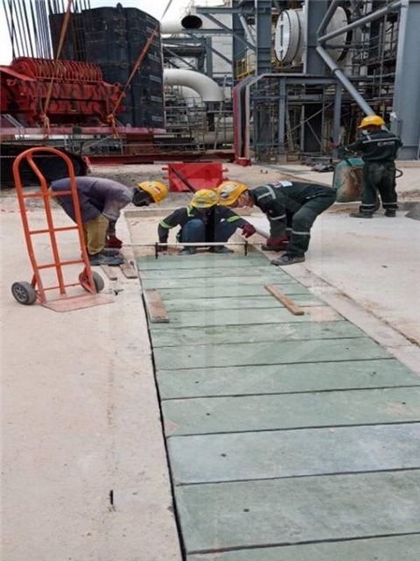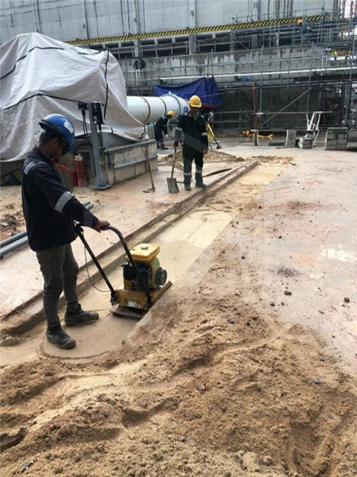

RNZ GOLDEN DEVELOPMENT SDN. BHD.

OUR PROJECTS

**2.PTD9111, Mukim Pengerang**

Project Title : PTD9111, Mukim Pengerang

Customer : Perinsind Samudra Sdn Bhd

Main Contractor : Artans Construction Sdn Bhd

Job Scope : Proposed Design & Build of 116,586 Gallon Suction Tank, Pump

House and 217,844 Gallon Elevated Tank and Associated Works

Location : Pengerang, Johor

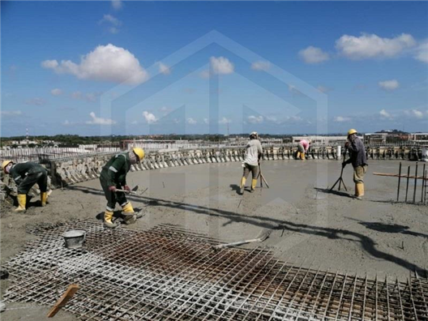Project Duration : Jun 2020 – Apr 2021

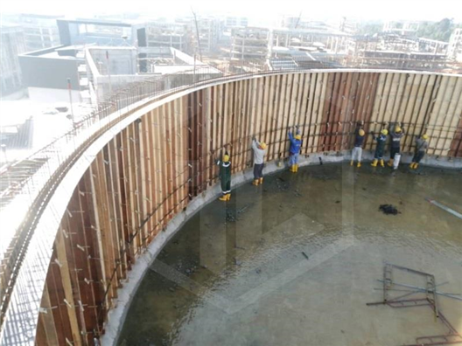

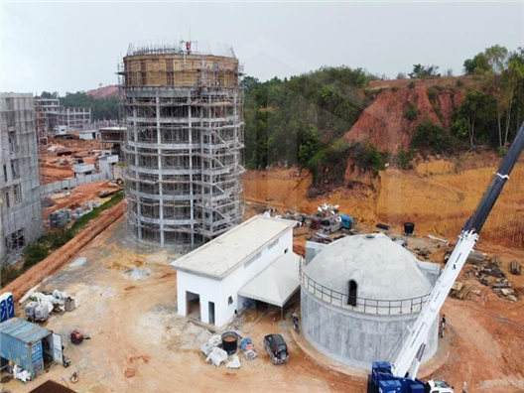

RNZ GOLDEN DEVELOPMENT SDN. BHD.

OUR PROJECTS

3.Ikano Johor Bahru

Customer : Ikea Malaysia

Main Contractor : China Construction

Duration : January 2018 – Present

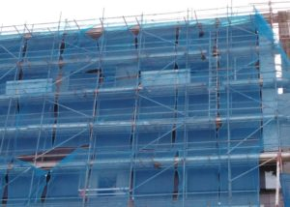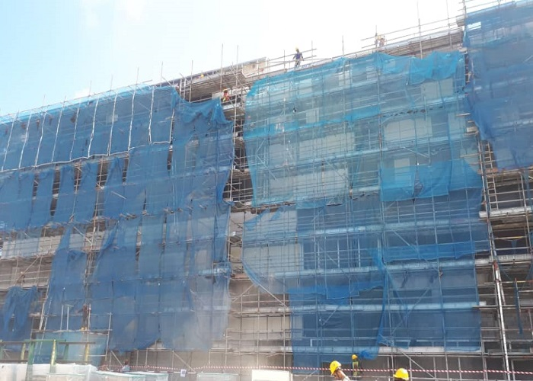

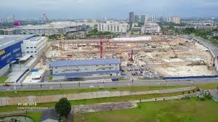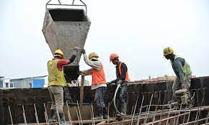

RNZ GOLDEN DEVELOPMENT SDN. BHD.

OUR PROJECTS

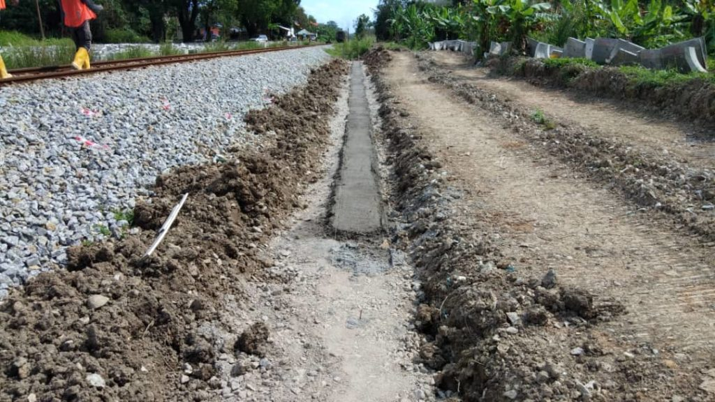**4.Drainage Work**

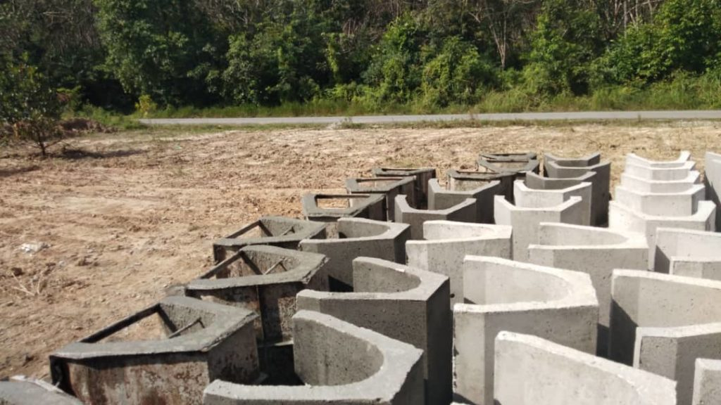

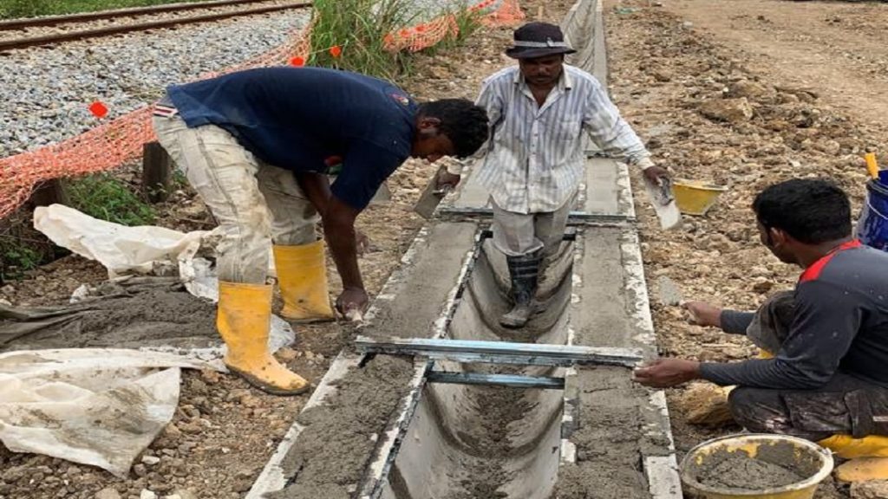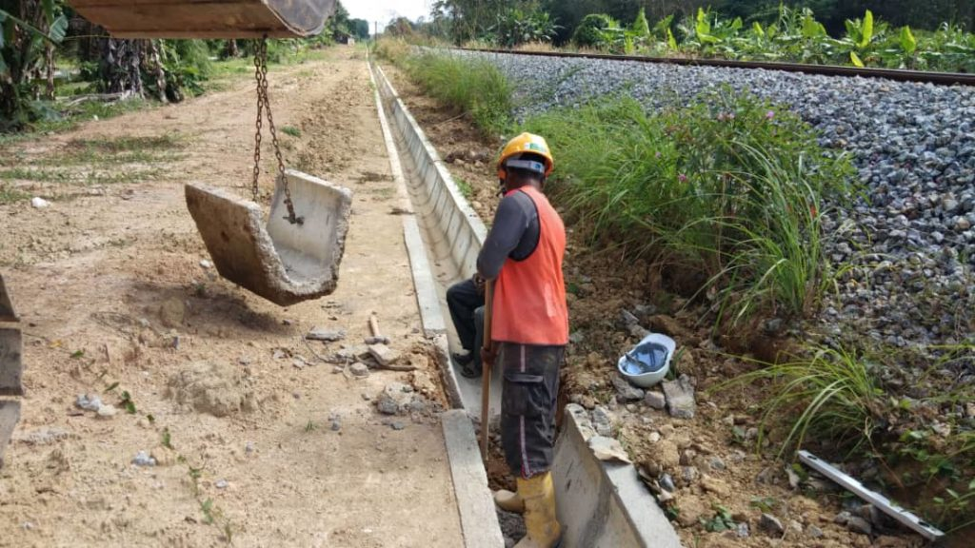

RNZ GOLDEN DEVELOPMENT SDN. BHD.

OUR PROJECTS

**5.Factory Construction**

Location: SILC OPALUS Factory Johor Bahru (JB), Malaysia, Skudai

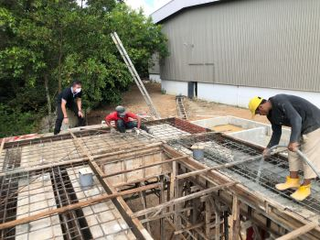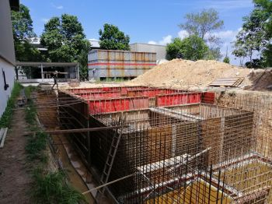

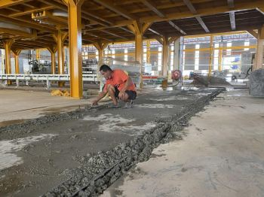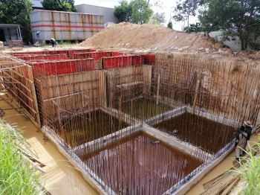

RNZ GOLDEN DEVELOPMENT SDN. BHD.

OUR PROJECTS

**5. Residential Construction**

Location: **Taman Sutera, Skudai, Johor**

**TYPES:** 3-Storey Terrace - 22’ x 86’ & 24’ x 86’

